Supplementary Table S1: Baseline characteristics of participants by follow-up status

|  |  |  |  |  |
| --- | --- | --- | --- | --- |
|  | Follow-up Status | | | |
| Characteristicsa | Remained  (N=24872) | Became ineligible  (N=8099) | Died  (N=4611) | Lost to follow-up  (N=14471) |
| **Number of teeth (2010)** |  |  |  |  |
| >= 20 teeth | 9717 (57.4%) | 1732 (10.2%) | 927 (5.5%) | 4558 (26.9%) |
| 10-19 teeth | 6616 (50.6%) | 1748 (13.4%) | 995 (7.6%) | 3726 (28.5%) |
| 1-9 teeth | 5561 (42.3%) | 2477 (18.8%) | 1340 (10.2%) | 3777 (28.7%) |
| Edentate | 2309 (32.0%) | 1781 (24.7%) | 1184 (16.4%) | 1943 (26.9%) |
| **Age (Years)** |  |  |  |  |
| Mean (SD) | 72.3 (5.0) | 78.9 (6.2) | 77.7 (6.7) | 73.0 (5.4) |
| **Sex** |  |  |  |  |
| Female | 13717 (49.2%) | 5013 (18.0%) | 1578 (5.7%) | 7574 (27.2%) |
| Male | 11155 (46.2%) | 3086 (12.8%) | 3033 (12.5%) | 6897 (28.5%) |
| **Household income (2010)** |  |  |  |  |
| Mean (SD) | 2.5 (1.6) | 2.2 (1.5) | 2.2 (1.6) | 2.3 (1.7) |
| (Missing) | 3377 | 2085 | 937 | 3031 |
| **Social participation 2010** |  |  |  |  |
| Everyday | 1098 (56.5%) | 199 (10.2%) | 112 (5.8%) | 533 (27.4%) |
| 2-3 times a week | 3912 (57.8%) | 779 (11.5%) | 382 (5.6%) | 1691 (25.0%) |
| Once a week | 3636 (55.7%) | 869 (13.3%) | 402 (6.2%) | 1622 (24.8%) |
| 1-2 times a month | 4163 (51.7%) | 1096 (13.6%) | 656 (8.1%) | 2141 (26.6%) |
| Few times a year | 4426 (48.3%) | 1251 (13.7%) | 889 (9.7%) | 2595 (28.3%) |
| Never | 5182 (39.8%) | 2529 (19.4%) | 1462 (11.2%) | 3838 (29.5%) |
| **Denture status (2010)** |  |  |  |  |
| Do not wear dentures | 10809 (50.9%) | 2815 (13.3%) | 1637 (7.7%) | 5978 (28.1%) |
| Wear dentures | 11883 (47.1%) | 4090 (16.2%) | 2437 (9.7%) | 6833 (27.1%) |
| **Marital status (2010)** |  |  |  |  |
| Widowed,divorced, or unmarried | 5947 (41.0%) | 3364 (23.2%) | 1380 (9.5%) | 3806 (26.3%) |
| Married | 18673 (51.0%) | 4505 (12.3%) | 3102 (8.5%) | 10335 (28.2%) |
| **Self-rated health (2010)** |  |  |  |  |
| Very good | 3364 (55.8%) | 529 (8.8%) | 349 (5.8%) | 1790 (29.7%) |
| Good | 18082 (50.7%) | 4823 (13.5%) | 2697 (7.6%) | 10053 (28.2%) |
| Fair | 2900 (34.1%) | 2227 (26.2%) | 1177 (13.8%) | 2207 (25.9%) |
| Poor | 296 (23.5%) | 379 (30.1%) | 328 (26.1%) | 256 (20.3%) |
| aMean (SD) for continuous variables; Frequency (%) for categorical variables | | | | |

Supplementary Figure S1: Distribution of missingness among baseline variables in relation to the outcome

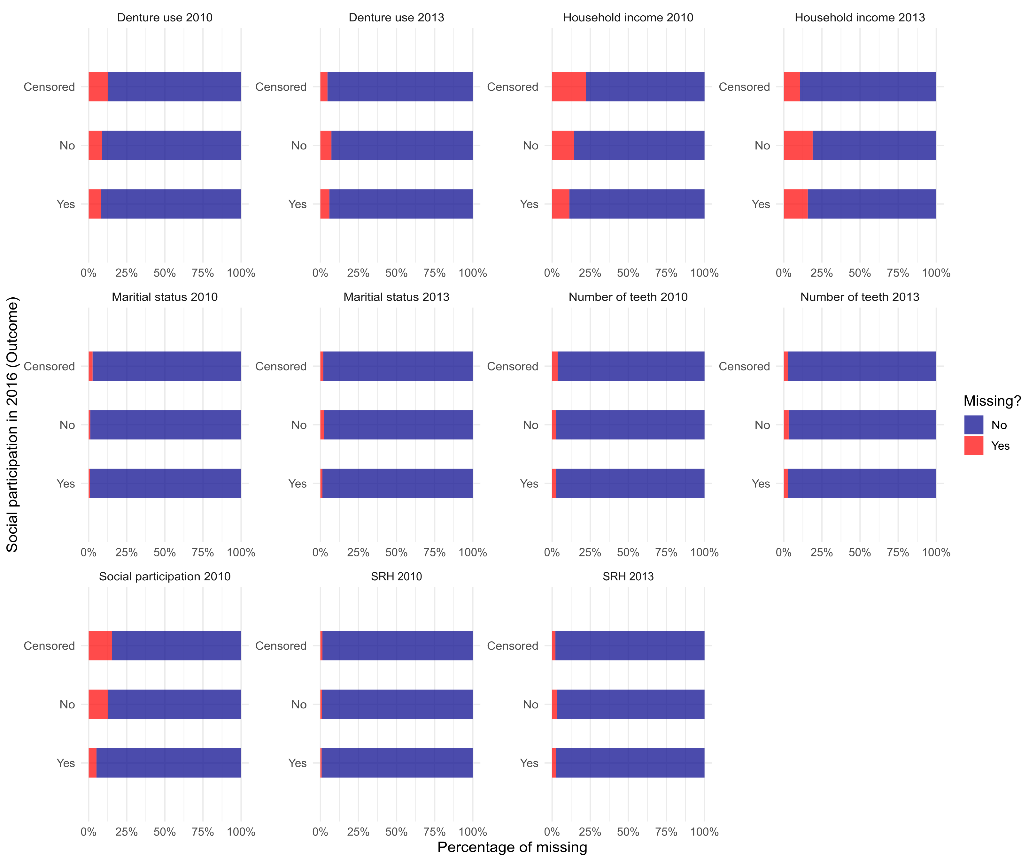

Supplementary Figure S2: Distribution of missingness among baseline variables in relation to the exposure

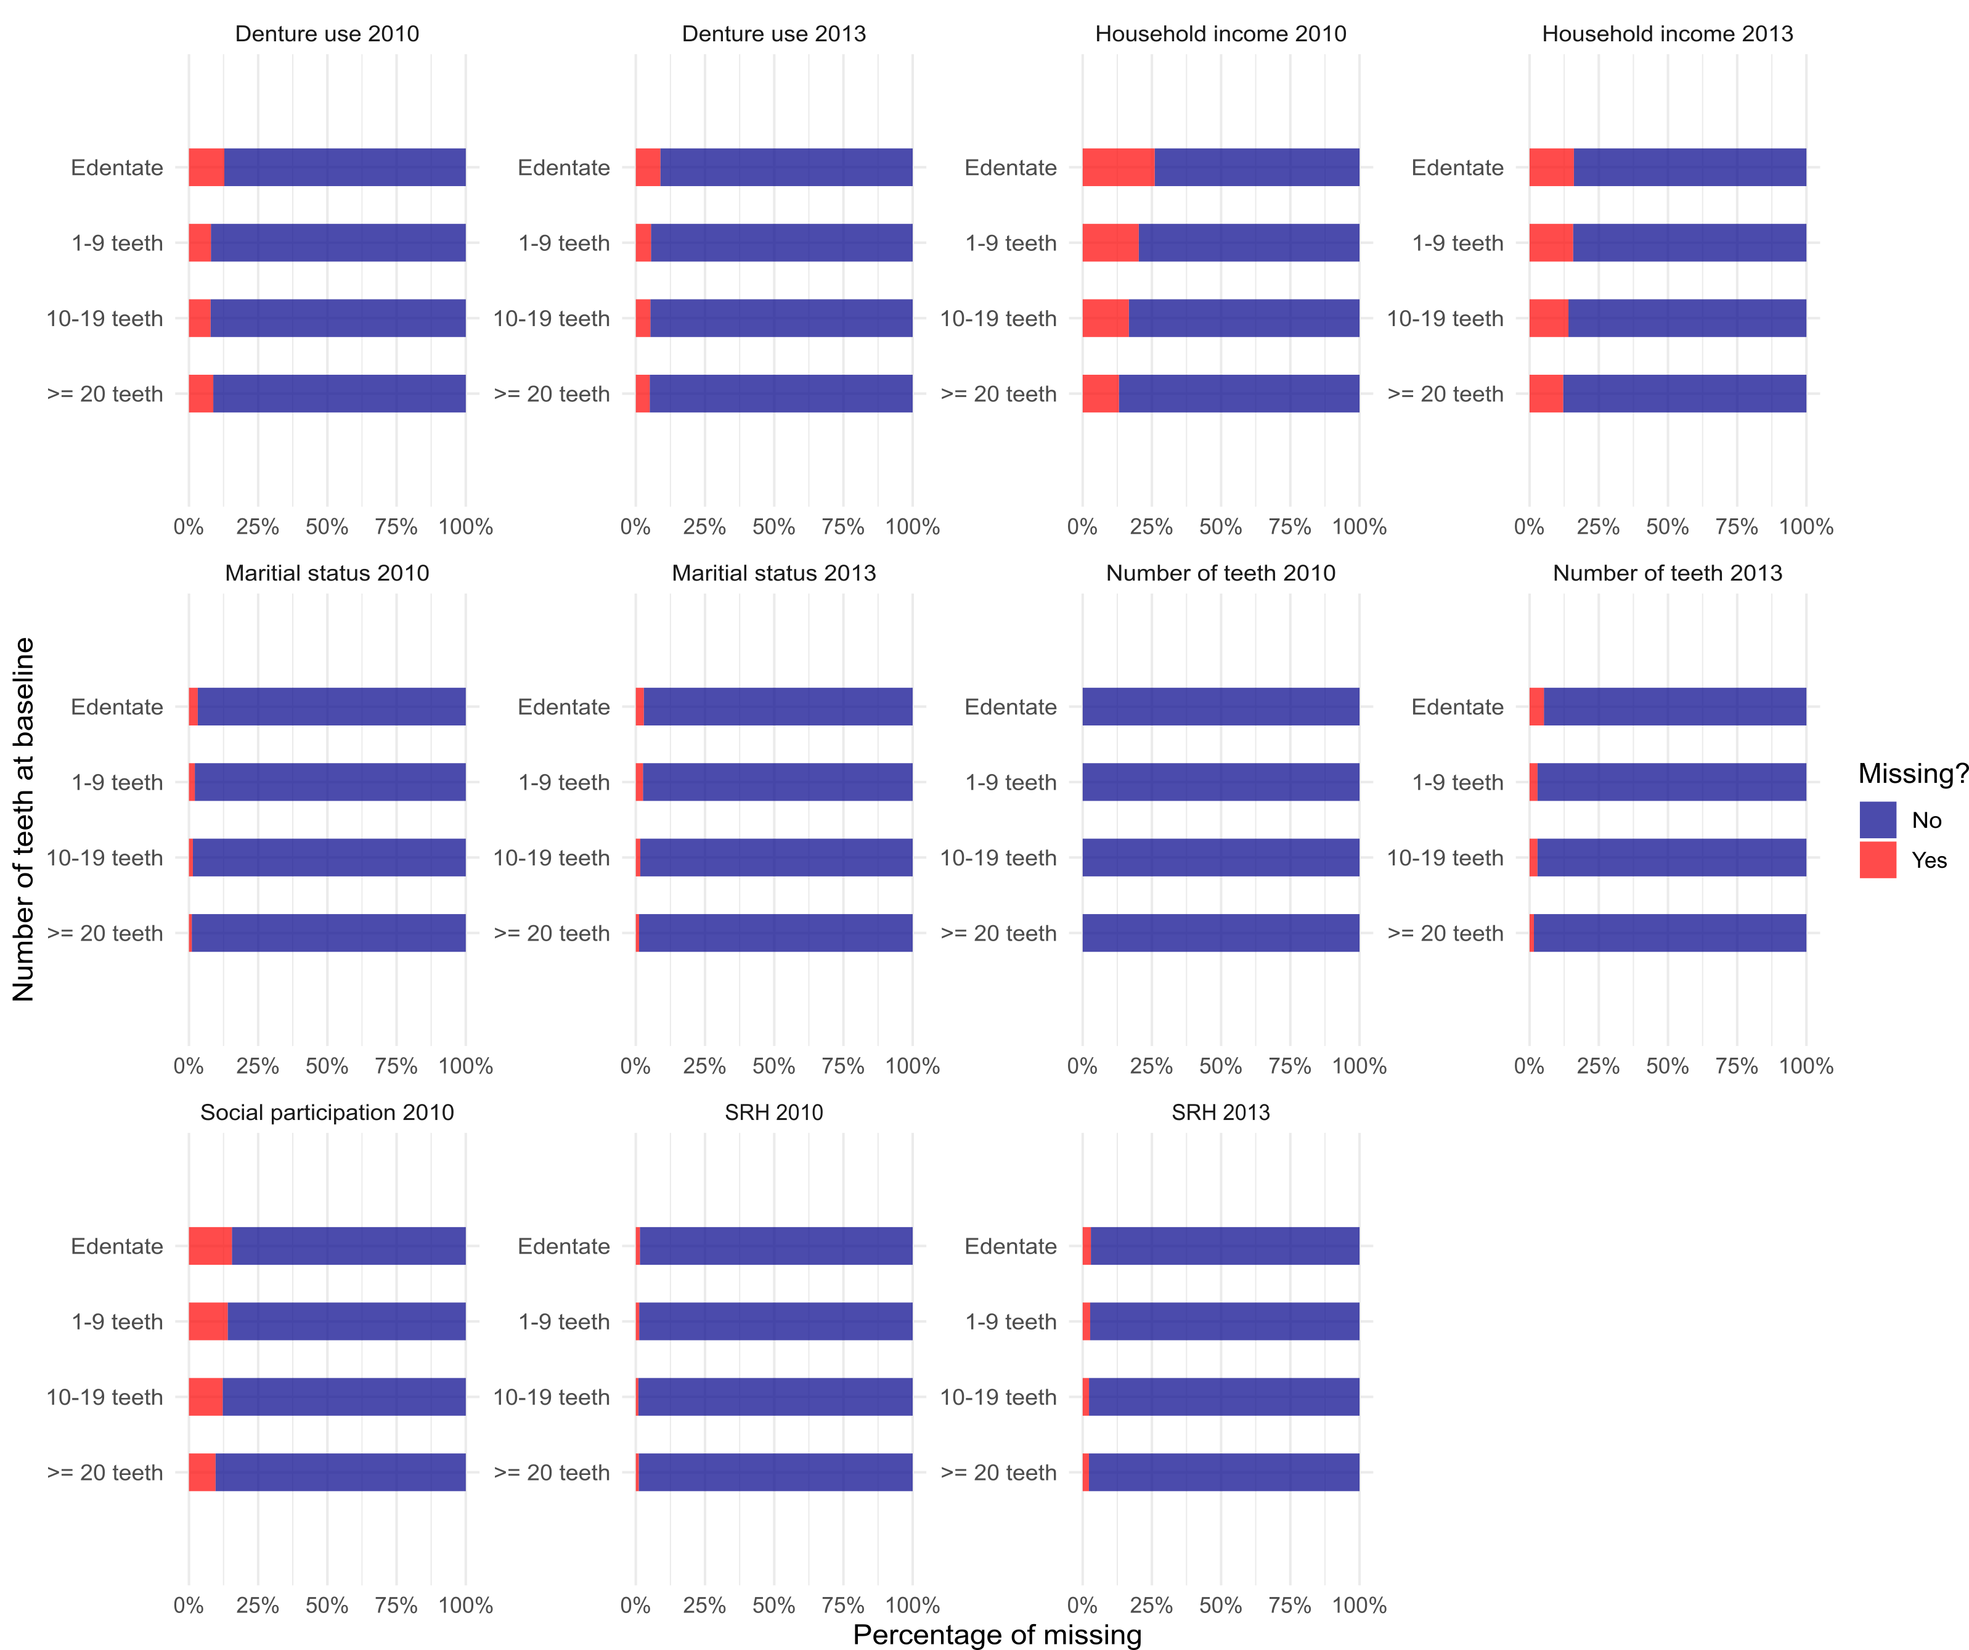

Supplementary Table S2: Results of TMLE analysis with complete cases

| Contrast | OR [95% CI] | P value | E-value |
| --- | --- | --- | --- |
| Observed vs Edentate | 0.80 [0.77-0.83] | < 0.000 | 1.81 |
| Observed vs 1-9 teeth | 0.97 [0.91-1.02] | 0.242 | 1.22 |
| Observed vs 10-19 teeth | 1.00 [0.94-1.06] | 0.998 | 1.00 |
| Observed vs >=20 teeth | 1.06 [1.03-1.09] | < 0.000 | 1.31 |
| Edentate vs 1-9 teeth | 1.21 [1.12-1.30] | < 0.000 | 1.71 |
| Edentate vs 10-19 teeth | 1.25 [1.16-1.35] | < 0.000 | 1.81 |
| Edentate vs Observed | 1.25 [1.20-1.30] | < 0.000 | 1.81 |
| Edentate vs >=20 teeth | 1.32 [1.25-1.40] | < 0.000 | 1.98 |

Supplementary Figure S3: Comparison of estimates with and without Super Learner (complete case analysis)

